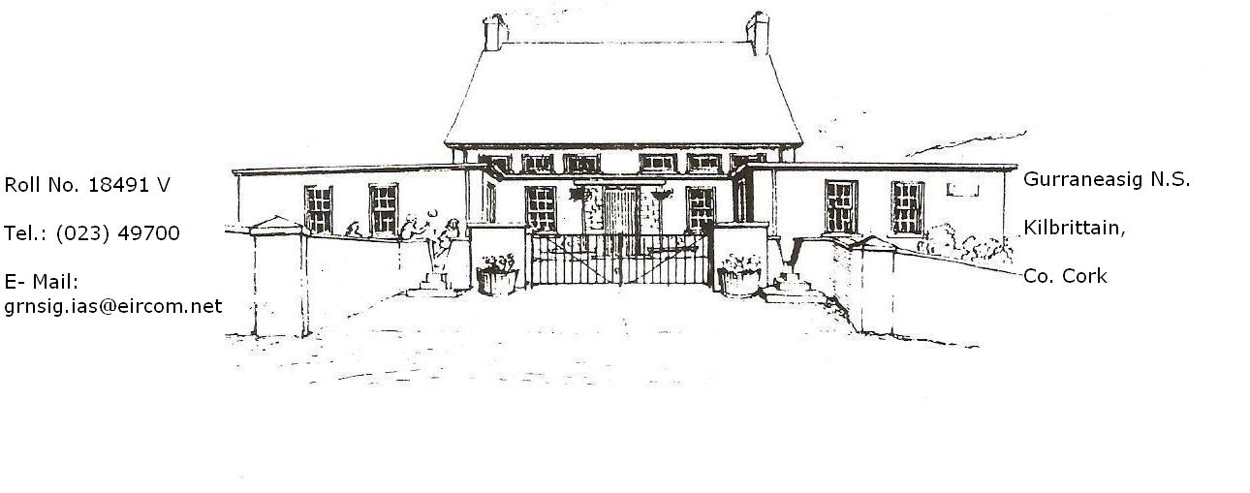

Accident

Policy

Whole School Plan

Rationale

The formulation of this policy enables our school to effectively –

- Provide for the immediate needs and requirements of students who have sustained either a serious or a minor injury

- Ensure that adequate resources and arrangements are in place to deal with injuries/accidents as they arise

- Ensure lines of communication with parents /guardians are in place if required.

- Activate a known plan of action with which all staff are familiar

School Ethos

This Policy re-enforces the elements of the school mission statement which advocates providing a safe and secure learning environment for each child and ensuring a duty of care at all time when the school is in operation.

Aims/Objectives

- To ensure the physical safety and well being of all staff and pupils
- To develop a framework of procedures whereby all injuries are dealt with in a competent and safe manner
- To comply with all legislation relating to safety and welfare at work

Roles and Responsibilities

The overall responsibility for the day-to-day management of school supervision / routines rests with the Principal. The class teacher is responsible for classroom supervision and teachers on yard duty are directly responsible for the supervision of pupils at break time.

Procedures

Safety of pupils and staff is a priority for the Board of Management, and measure have been put in place to ensure no children or staff members are put at risk.

- A comprehensive school Safety Statement has been recently revised whereby all hazards are identified and remedial measures are outline, if required.

- The school is insured under Allianz and a 24 hours policy is in place for all the children

- Each classroom teacher regularly instructs his/her class on issues relating to safety in the class/yard. Dangerous practices such as climbing trees, climbing walls, throwing stones, running fast in the Infants areas, engaging in “horseplay”, fighting etc are subject to severe sanctions (see school Anti-Bullying and Discipline Policies)

- Certain Procedure are in place in the event of accidents.

- There is at least one (1) teacher and the SNA on yard duty at any one time.

Minor Accident/ Injury

The injured party is initially looked after by the teacher on yard duty. If deemed necessary, the child will be taken inside to a classroom. No medicines are administered but cuts are cleaned and bandages / plasters applied if deemed appropriate. The use of plastic gloves is advised at all times. Parents are notified as a matter of protocol.

More Serious Accidents / Injuries

If considered safe to do so, the injured party is brought inside. Parents/Guardians are immediately informed, particularly if there is a suspicion of broken bones / head or eye injuries. If Parents/Guardians are not available then the contact number given on the Enrolment Form will be communicated with.

Very Serious Injuries

In the event of a very serious injury, Parents/Guardians are immediately contacted. If the considered opinion of the staff is that immediate professional help is required, and ambulance is called. Parents/Guardians are kept informed on developing situations.

Resources

First Aid Boxes are located in the Staff Room. All staff are aware of this location. The contents of such boxes are replenished when deemed necessary.

Record Keeping

All accidents / injuries are recorded in the Accident Report Book which is located in the Staff Room. The Accident Report form lists date and time of accident, witnesses, nature of injuries, a brief description of the circumstances of the accident, procedures followed by staff etc.
Very Serious injuries will be notified to the Schools Insurers on the Special Incident Report Form.
Relevant medical information on all pupils is obtained at time of enrolment on a special section of the schools enrolment form. This section asks parents to list allergies and other medical conditions their child may have.

Evaluation

The success of this policy is measured from a set of criteria:-
Maintaining a relatively accident free school environment
Positive feedback from staff, parents & children
Continual yard observation of behaviour b all staff engaged in supervision duties
Monitoring and evaluation at staff meetings

Ratified by Board of Management on __________________
Date

Signed __________________________________________
Chairperson, Board of Management

